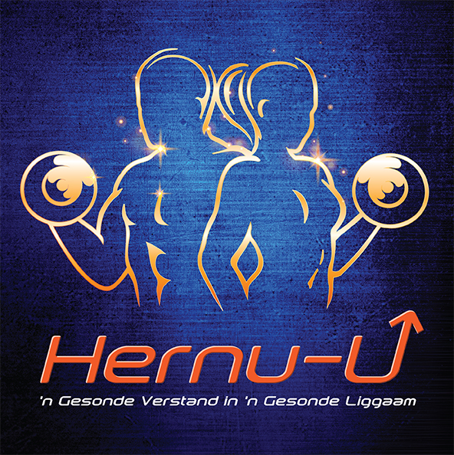

Persoonlike afrigting

kliënt-toelatingsvorm/ *PERSONAL TRAINING CLIENT INTAKE FORM*

* Laai hierdie vorm af, voltooi dit en e-pos dit terug om aansoek te doen vir afrigting. Jy kan nie die lêer direk op die Google webblad invul nie.*/ Download this form, fill it in and email it back to me to apply for coaching. You cannot edit the file directly from the Google Sheet.*
* Jy kan òf die imperiese òf die metrieke stelsel gebruik om die vorm in te vul. Dui slegs aan watter stelsel jy gebruik (bv. cm, kg, pd, dm).*/ You can use either the imperial or metric system to fill in this form. Just state which unit you used (e.g. cm, kg, lb, inch).*

# Algemeen/General

|  |  |
| --- | --- |
| * Volle naam en van/*Full name & surname* |  |
| * Selfoonnommer/*Cellphone* |  |
| * Eposadres/*E-mail* |  |
| * Stad/*City* |  |
| * Land/*Country* |  |
| * Ouderdom/ *Age* |  |
| * Lengte/ *Length* |  |
| * Gewig/ *Weight* |  |
| * Persentasie liggaamsvet *(indien bekend en*   *metode van berekening?)/Bodyfat percentage (if known and method used for calculations?)* |  |
| * Aantal jare reeds afrigting ontvang/ *Years of training experience* |  |

# Kragvlak/*Strength level*

Stipuleer huidige maksimum vermoë met gewigte en aantal reps (repetisies) bv. 80kg x 6 indien bekend./ *State your current maximum abilities in weight times reps, e.g. 80kg x 6 if known.*

|  |  |
| --- | --- |
| * *Bench press* |  |
| * *Squat* (liggaamsgewig uitgesluit/ *body weight excluded*) |  |
| * *Chin-up* (liggaamsgewig uitgesluit/ body weight excluded) |  |
| * *Overhead press* |  |

# Doelwitte/ *Goals*

# Wat is jou fiksheidsdoelwitte?/*What are your fitness goals?*

|  |
| --- |
|  |

## Is daar enige groep spiere wat jy nie groter of sterker wil maak nie?/ *Do you have any muscle groups you do not want to get bigger?*

|  |
| --- |
|  |

## Wil jy ander oefeninge doen saam met kragoefeninge/*strength training* (bv. sokker, joga, Olimpiese gewigstoot)?/ *Do you want to perform any other form of exercise alongside strength training (e.g. soccer, yoga, Olympic Weightlifting)?*

|  |
| --- |
|  |

## Watter van die volgende keuses beskryf jou toewydingsvlak die beste?/ *Which of the following options best describes your dedication level?*

A: Volhoubaarheid is vir my die belangrikste. Net solank ek die regte metode volg, gee ek nie om oor die vorderingstempo nie./ *Sustainability is most important to me. As long as I’m moving in the right direction, I don’t care about the rate of progress.*

B: Ek wil ‘n balans handhaaf tussen goeie uitslae in verhouding met die mate van inspanning en volhoubaarheid./ *I want to strike a reasonable balance between good results in proportion to effort and sustainability.*

C: Ek wil alles in my vermoë doen om die beste resultate te bereik sonder om my gesondheid in gevaar te stel./ *I will do whatever it takes to achieve maximum results without compromising my health.*

|  |
| --- |
|  |

## Hoeveel keer per week is jy bereid om te oefen om die beste resultate te bereik?/ *How often in a week are you prepared to train for maximal results?*

|  |
| --- |
|  |

# Allerlei/ *Misc.*

## Wat is jou beroep?/ *What is your occupation?*

Jy kan in die algemeen antwoord, bv. bestuursposisie/persoonlike afrigter/rekenaartegnologie/dokter. Die doelwit is om jou biologiese ritme, spanningsvlak en aktiwiteitsvlak te bepaal*./ You may be general here, e.g. manager/personal trainer/IT/doctor. The aim is to characterize your circadian rhythm, stress and activity level.*

|  |
| --- |
|  |

## Maak asb. ‘n lys van enige siektes en besering (gebreke, allergieë, sindrome, versteurings, ens.) wat jy ondervind of ondervind het./ *Please list any pathologies and injuries (disabilities, allergies, illnesses, syndromes, disorders etc.) you have or had.*

|  |
| --- |
|  |

## Dring jy aan op ‘n spesifieke dieët (bv. keto, vegan)?/ *Do you insist on any special diet (e.g. ketogenic, vegan)?*

|  |
| --- |
|  |

## Het jy ondervinding met *calorie tracking* en makro-voedingstowwe?/ *Do you have experience with calorie tracking and macronutrients?*

|  |
| --- |
|  |

## Beplan jy om PEDs/*Performance enhancing drugs* te gebruik tydens die afrigting? Indien wel, maak asb. ‘n lys daarvan./ *Do you plan to use any PEDs while working together? If so, please list them.*

|  |
| --- |
|  |

**Indien so verkies, mag jy op hierdie stadium die vorm terugstuur na *hernu.u.vandag@gmail.com* om ‘n kwotasieprys te kry voordat jy die res van die vorm voltooi.**

Heg asb. ten minste twee duidelike vollengte foto’s van jouself aan, sodat jou huidige liggaamsbou geëvalueer kan word.

*Wetlike afstanddoening: Met die terugstuur van hierdie vorm onderneem jy dat alle middels wat jy verkry en gebruik in ooreenstemming met die voorskrifte is en jy verbeur alle reg om Susan Fouché verantwoordelik te hou vir enige skade gely terwyl jy haar raad as persoonlike afrigter gevolg het.*

**At this point, you may choose to return this form to *hernu.u.vandag@gmail.com* to obtain a price quote before filling in the rest.**

Please attach at least two clear full-length photographs of yourself, so that your current physique can be evaluated.

*Legal Waiver: By returning this form, you undertake that all drugs you obtain and use are in accordance with the prescriptions and you forfeit all rights to hold Susan Fouché responsible for any damages suffered while following her advice as a personal trainer.*

# Lewenstyl/*Lifestyle*

## Is daar tye wat jy nie kan nie of verkies om nie te oefen nie?/ *Are there any times at which you are unable or unwilling to train?*

## Dit sluit tye in wat jy by die werk is. As jy nie hierdie vraag noukeurig beantwoord nie, kan jy dalk ‘n program kry wat jy nie sal kan volg nie (!)/*This includes when you’re at work. If you don’t answer this question accurately with detailed times, you may get a program you can’t follow(!)*

|  |
| --- |
|  |

## **Watter van die volgende keuses beskryf jou dag tot dag vlak van aktiwiteit die beste, afgesien van jou beplande oefensessies?/ *Which of the following options best describes your day to day activity level aside from your planned training sessions?***

|  |  |  |
| --- | --- | --- |
| * Onaktief (bv. kantoorwerk met gewone huiswerk)/ *Sedentary (e.g. office job with standard life chores)* |  |  |
| * Effens aktief (bv. jy pendel ‘n redelike afstand per fiets)/ *Somewhat active (e.g. you have a long commute by bicycle)* |  |  |
| * Aktief (bv. voltydse oefeninge, letterlik op jou voete die grootste deel van die dag)/ *Active (e.g. full-time PT, literally on your feet most of the day)* |  |  |
| * Baie aktief (bv. betrokke by handearbeid)/ *Very active (e.g. involved in manual labor)* |  |  |

## **Watter van die volgende keuses beskryf jou vlak van spanning?/ *Which of the following options best describes your stress level?***

|  |  |
| --- | --- |
| * Geen spanning (bv. met vakansie of afgetree)/ *Stress-free (e.g. on holiday or retired)* |  |
| * Net af en toe matige inspanning (bv. ‘n student buite eksamentyd)/ *Only occasional/mild stress (e.g. student outside of exam periods)* |  |
| * Middelmatige inspanning (bv. voltydse werk waar dit nodig is om te pendel)/ *Average stress (e.g. full-time work with a commute)* |  |
| * Hoë spanning (bv. hoë-impak werksomgewing met groot verantwoordelikheid)/ *High stress (e.g. very high-paced work environment with great responsibility)* |  |

## Beskryf jou gehalte van slaap en slaappatroon?/ *How is your sleep rhythm and quality?*

|  |
| --- |
|  |

## Hoeveel kafeïen neem jy gemiddeld daagliks in?/ *How much caffeine do you consume daily on average or on a typical day?*

|  |
| --- |
|  |

## [Slegs vir vrouens] Het jy ‘n normale menstruele siklus? Gebruik jy enige voorbehoedmiddels? Is jy swanger*?/ [Women only] Do you have a regular menstrual cycle? And are you using any form of contraception? Are you pregnant?* (Indien jy voel dat hierdie vrae te sensitief is, is jy welkom om dit te ignoreer, maar met volledige inligting, kan ek jou beter help./*If these questions are sensitive, feel free to ignore them, but the more information I have, the better I can help you.)*

|  |
| --- |
|  |

# Toerusting/ *Equipment*

## Besit jy ‘n instrument om liggaamsvet te meet (*skinfold caliper*) en indien wel, watter maak en model?/ *Do you have skinfold calipers and if so, what’s the brand and model?*

|  |
| --- |
|  |

## Wat is die ligste *barbell weight plates* waartoe jy toegang het?/ *What are the lightest barbell weight plates you have access to?*

|  |
| --- |
|  |

## Wat is die kleinste gewigsinkremente tussen die verskillende stelle *dumbbels* waartoe jy toegang het?/ *What are the smallest weight increments between the sets of dumbbells you have access to?*

|  |
| --- |
|  |

## Het jy toegang tot/ *Do you have access to*:

|  |  |
| --- | --- |
| * *Squat cage or rack?* |  |
| * *45° Hyperextension bench?* |  |
| * *Reverse hyper machine?*   Image result for reverse hyper machine |  |
| * *Glute-ham raise?*   http://www.legendfitness.com/Uploads/images/7006-HI.jpg |  |
| * *Dip/chin-up belt?* |  |
| * *Leg curl machine* … en indien wel, is dit een waarop jy sit (a), lê (b) of staan (c)/ *and if so, is it  seated (a), lying (b) or standing (c)*? * *Leg extension machine?* |  |
|  |
| * *Pair of knee wraps?* |  |
| * *Gymnastic rings?* |  |
| * *TRX or similar suspension device?* |  |
| * *Powerlifting bands* (*nie* die ligte tuisoefensoort nie/ *not the light home workout kind)*? |  |
| * *Powerlifting chains?* |  |
| * *Seated calf raise* … en indien wel, is dit ‘n geslote ketting waar dit nodig is om jou liggaam op te stoot (kyk na die voorbeeld hieronder) of is dit ‘n ander sort/ *and if so, is it closed chain where you push your body up (see example image below) or different*?   http://www.predatornutrition.com/wp-articles/wp-content/uploads/SeatedCalfRaise.jpg |  |
| * *Cable tower* en indien wel, is dit verstelbaar/ *and if so, is it adjustable*? |  |

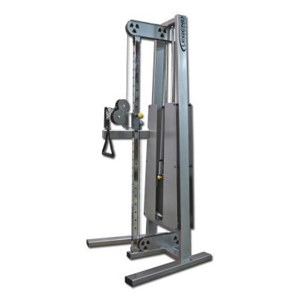

Let daarop dat dit nie nodig is om toegang tot al die bogenoemde gim toerusting te hê om ‘n goeie oefenprogram te hê nie*. / Note that you don’t need access to all of the above equipment to have a good training program.*

## Verskil jou beskikbare *gim toerusting* van dit wat in die meeste gimnasiums gebruik word (bv. jy oefen in ‘n *Crossfit box* of jy oefen tuis)?/ *Does your available equipment differ from that in most gyms in any other way (e.g. you train in a CrossFit box or at home)?*

|  |
| --- |
|  |

# Aanvullings/*Supplements*

Skryf asb. al die aanvullings wat jy neem, neer*./ Please list all supplements you’re currently taking.*

|  |
| --- |
|  |

# Geneties/ *Genetics*

|  |  |
| --- | --- |
| * Pols omtrek (dunste plek)/ *Wrist circumference (smallest point)* |  |
| * Enkel omtrek (dunste plek)/ *Ankle circumference (smallest point)* |  |
| * Hoeveel het jy geweeg voordat jy met gewigte begin oefen het en wat was jou lengte toe?/ *How much did you weigh before you started lifting and what was your height at that point?* |  |
| * Was jy ‘n groot baba?/ *Were you heavy as a baby?* |  |

Sluit asb. ‘n foto in waar die agterkant van jou regterhand duidelik sigbaar is. Plaas jou regterhand op ‘n plat oppervlak met jou palm na bo en raak met elke vinger aan die ander terwyl jy ‘n foto daarvan neem. / *Please attach a picture to this form in which the back of your right hand is clearly visible: place your right hand on a flat surface with your palm up and your fingers touching each other and then take a picture of it.*

# 

# Huidige Program/*Current Program*

Beskryf asb. in detail jou huidige dieëtplan of heg dit aan.*/ Please describe or attach your current diet plan in detail.*

|  |
| --- |
|  |

Gee ‘n volledige beskrywing van jou huidige oefenprogram of heg dit aan.*/ Please describe or attach your current training program in detail.*

|  |
| --- |
|  |

Stuur asb. die voltooide vorm terug na ***hernu.u.vandag@gmail.com*** en heg ten minste twee duidelike vollengte foto’s van jouself aan (sonder te veel skaduwees en beslis nie jou mees vleiende *Facebook* foto nie).

As jy onlangs bloedtoetse laat doen het, sal jy asb. ook die resultate saamstuur. / *Please return the completed form to* ***hernu.u.vandag@gmail.com*** *and attach at least two full-body pictures of yourself in clear lighting (without excessive shadows; not your most flattering Facebook selfies).*

*If you recently had blood work done, please attach its results as well.*